BIOC 455
Lecture # 27– Catecholamines: Basic features
Lecturer: Dr. Marco Leyton – Fri. March 16th, 2007

NOTE: This NTC is meant to be used as a study aid to supplement your own class notes. Hence, not all of the text or diagrams contained in the lecture slides will be reproduced here.

Please send any comments or questions about NTCs to either Wanda or James through e-mail at u3.represent@gmail.com .

Professor Leyton has put text for each slide (available on WebCT).
What we are going to start today is looking at the role of the system and behaviour. Again, primarily with Dopamine (DA) and we will talk a bit about Norepinephrine (NE).

<Slide 1>
Catecholamines & Behaviour
Initiation of movement
Reward
Focused attention
Catecholamines and Dopamine in particular have been implicated in a very broad sense linked to the types of behaviour on the initiation of movement, on responses of rewards, judgement above the rewarding characteristic of the environment stimuli and go to focus on attention.
The catecholamines, Dopamine (DA) and Norepinephrine (NE) are probably working together to produce these effects. DA and amphetamine play an important role on behaviour.
We are going to go through the history of that idea.

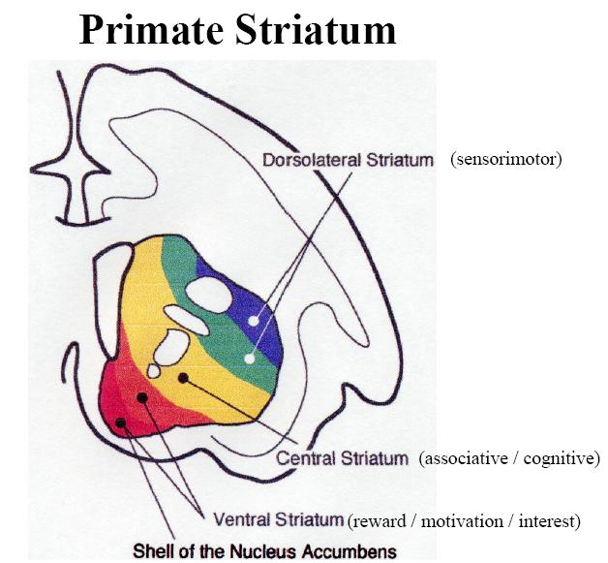
<Slide 2>
This is a Primate Striatum, probably taken from research monkey but the human striatum is very much like this also. This is the left striatum which is separated into different segments. This is much more a gradation of the subcompartments that receive input from other parts of the brain and turns to the behavioural relevant to the tag. The ventromedial part of the striatum, “ventro-” means the bottom and “medial” for the midline of the brain, so the ventromedial part of the primate striatum correspond functioning what we usually call the Nucleus Accumbens in the rat first of all. This part of the brain receives really dense input from a cortical structure that we call part of the limbic system.
What does limbic system refer to?
The whole theory of interconnected parts of the brain is seen to be related to the fresh food, the feeling of the emotion, the respond emotion relevant stimuli.
An interesting history in that theory is that it began looking at a dog that had radi and one of the behavioural references of radi is the roughly mad ray, not only it feels bad and in this real destruction of any kind of emotional regulation. They thought there were been parts of the brain that particularly seem to be destroyed and now gave them the idea that certain parts of the brain might be particularly important for emotion and then that was sort of the way the idea that the limbic brain through that concept being developed.
Since then people have identified other parts of the brain connected with those structures, all together are what we call the Limbic Brain. Those structures and particularly the core structures that are part of the limbic system project really quite intense density especially to this ventromedial part of the striatum.
What do we know more about the dorsolateral then we previously suspected other than they are much more gradation than the cartoon? The central part of the striatum, you see all in addition to the gradation of the limbic system you see input from the parts of the brain that are involved in associative and cognitive types of function. The dorsolateral prefrontal cortex (DLPFC), dorsal being top and lateral being side (close to the midline). DLPFC plays a really important role in working memory and complex thinking. This sends dense input to this central part of the striatum and again we get circuit, but the cortex through the striatum and this circuit together regulate thinking about what to do and then finally the dorsolateral part of the striatum receive the dense input from the sensorimotor cortex. The motor cortex plays a really important role in planning out the physically movement.

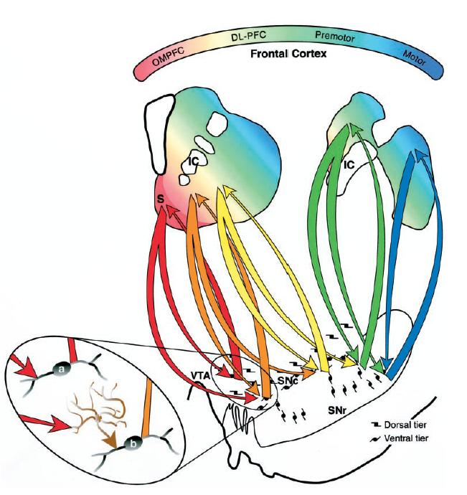
<Slide 3>
In addition to receive variant input from different parts of the cortex, we can also distinguish different parts of the striatum based on DA input in the DA cell body, remember we’ve talked about the two main DA cell body: Ventral Tegmental Area (VTA) and Substantia Nigra (SN) and these two cell body system in the upper brain stem sits really side by side. Over last three years, it becomes clear that these different systems through a series of “spiralling move” actually receive and forward into each other. The information can be passed starting from the most limbic reward/motivation/emotional part of the striatum through the cognitive part of the striatum and then eventually to the sensory motor part. The red line is the DA cell projecting to the limbic part of the striatum and then this limbic striatum send descending feedback pathway right back to the same cell, Nucleus Accumbens, (so from the DA cell up to the striatum back down to the Nucleus) providing regulatory feedback. But the same cells that were projected up to the striatum, they are also descending that actually send their projecting a bit more medial, to the next set of DA cell and in turn they send their DA cell up to the central part of striatum and then get descending pathway back to the same region then go to another descending pathway over and over again. All lead to a series of spiralling movement. This allows the information to get transferred. The series of information going through from one part of the cell moved to the next.

<Slide 4>
Initiation of Movement
The best studied role of nigrostriatal DA is in the initiation of movement.

<Slide 5 - Top>
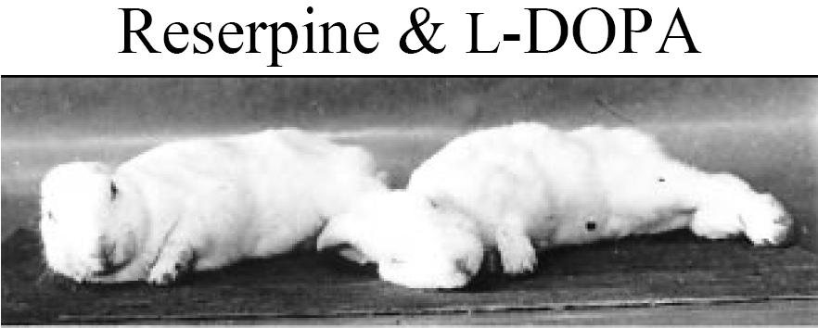
A seminal work from Arvid Carlsson’s in the 50s to early 60s. He won a Nobel Prize in 2000. He gave a drug called Reserpine to bunny. Reserpine has depressant effect. Inside a catecholamine cell, once they’ve been produced and transmitted in the cell, they are stored in the vesicles and protected from Monoamine Oxidase (MAO). Reserpine causes vesicles to irrupt and all the transmitters are out of the storage vesicles into the cells to whether both monoamine oxidases, the enzymes that break down the transmitters.
When they did the experiment, they weren’t clear what the reserpine was doing. They gave this drug to the bunny and the bunny stayed immobile. They collapsed on the floor and couldn’t get any move. Then they gave them L-DOPA, which is the mediate precursor of dopamine (DA), but at this time, DA wasn’t thought to be a neurotransmitter (NT), DA was just thought to be the raw material of Norepinephrine (NE), (remind: L-DOPA→DA→NE(=NA) →Epinephrine(=Adrenaline)) so they gave the L-DOPA and they thought they would restore these catecholamines. And this is what happened.

<Slide 5 - Bottom>
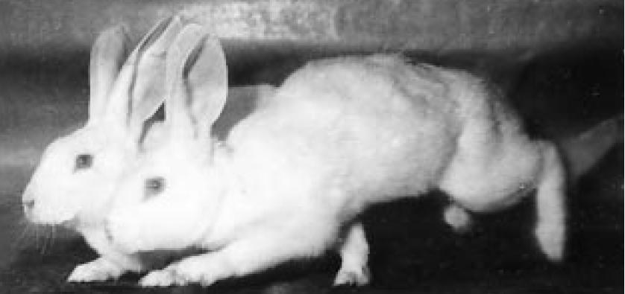
They gave L-DOPA and the bunnies were bouncing again.
The next thing they did, they went looking in the brain, and the exact expectation was that this restoration of behaviour was going to be related to the restoration of NE and Epinephrine, but they didn’t see that. The NE level was not restored and what was restored was DA.

<Slide 6>
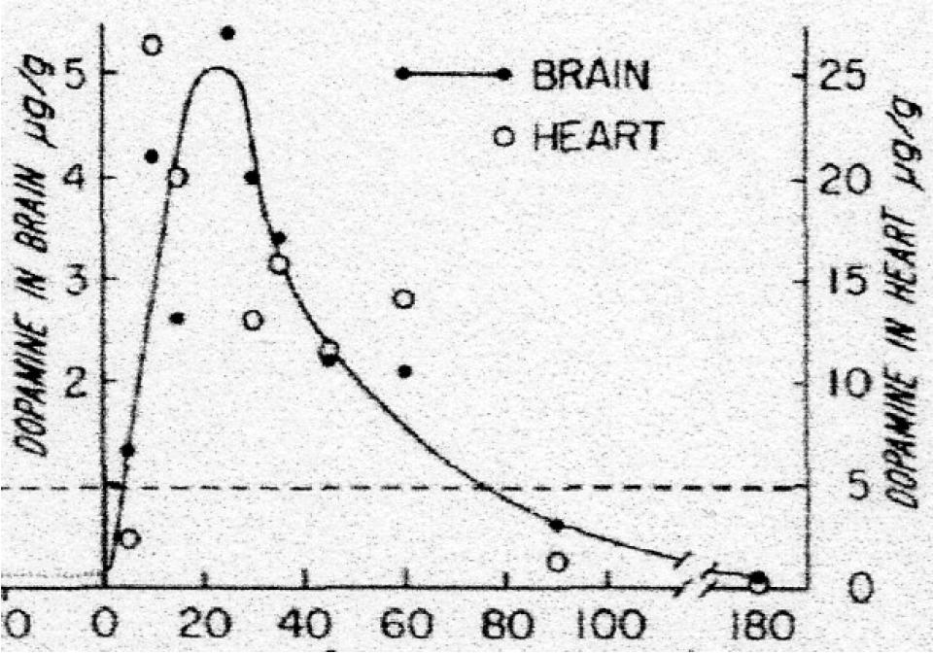
The DA level went back up when they gave L-DOPA but not NE. This is the beginning of the evidence that DA itself is functioning as a transmitter.

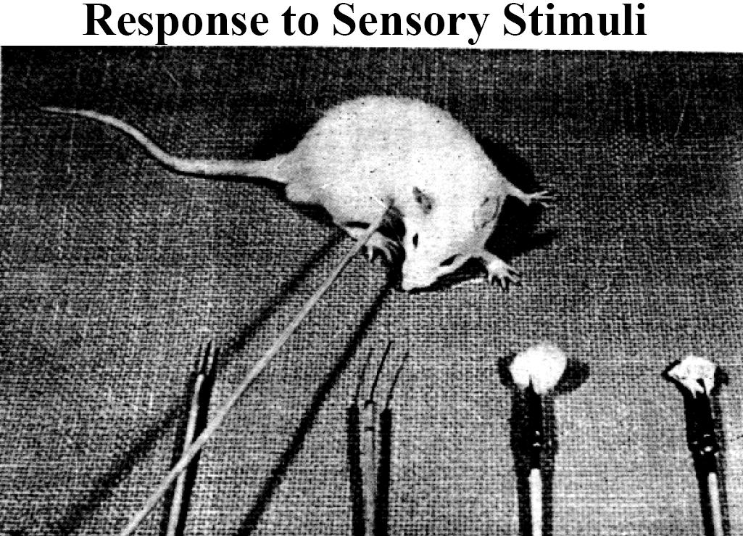
<Slide 7>
Following that, people started to get a little more specific type of approach. They performed various manipulations in animal, for examples, a rat being poked by a stick, sometimes a sharp needle. “Other tested stimuli were olfactory (cotton ball soaked in xylol, a sweet-smelling liquid), various touch stimuli, auditory (click 20mm from ear, visual (placed at edge of table).” Sometimes, they would pick up the rat and put it at the side of the table to see how it responded. All the tests were done to get a sense how they are going to respond to the environment.

<Slide 8>
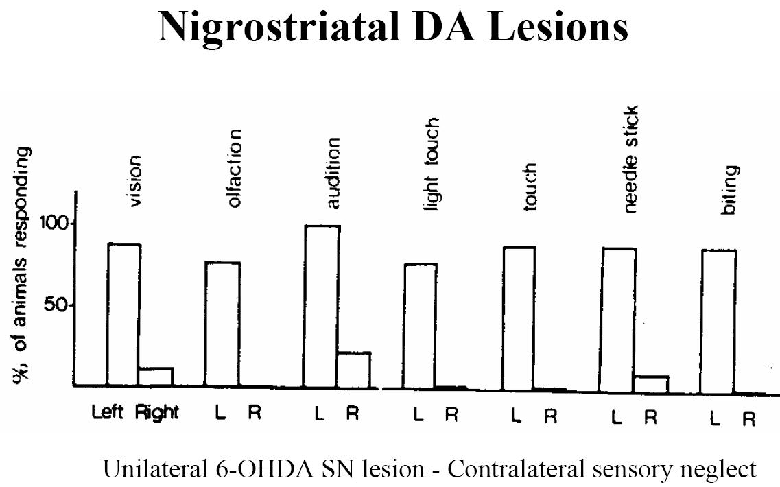
What they found is that they destroyed the DA system selectively on one side of the brain, the animal were sensory neglect of the stimuli on the other side, Contralateral neglect.
What do we really mean by contralateral? If you destroy the DA system in the left side of the brain of the animals, they will be ignoring the stimuli on the right side.
Why is that? Because the innervations from one side of the brain crosses over by enlarging, not complete, but almost entirely from one side crosses over to the other side. So if you destroy the DA cell, you get one side from the animal that will ignore all the different stimuli on the other side.

<Slide 9>
Reward
A very large literature implicates mesolimbic DA as playing an important role in reward/ reinforcement.

<Slide 10 - Left>
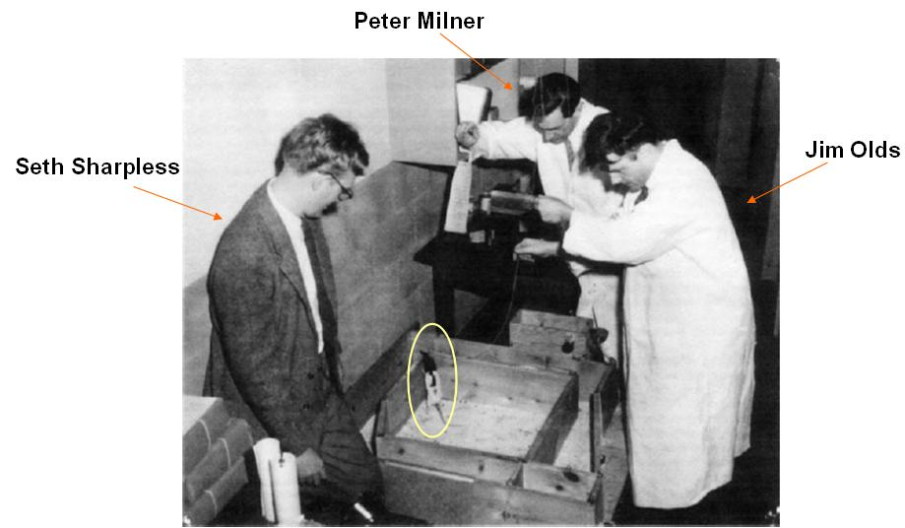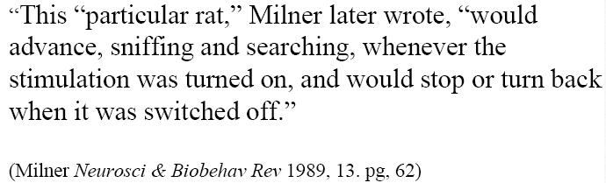
Another seminal study was going on during the same decay. This is the first electrical brain stimulating study done by Peter Milner and Jim Olds at McGill lab. They were sticking an electrode into the various parts of the brain, stimulating activity within the brain electrically to see how they change behaviour. It was the new technique at the time, very exciting. They stuck an electrode into the brain. They were aiming for Reticular activating system. Part of the preparation of the study, they wanted to find out and to confirm that stimulating part of the brain wasn’t just horrible for the animal.

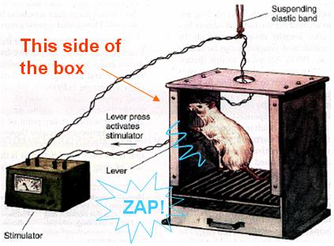
<Slide 10 – Right>
(a) The animal walked in the box and every time when it ended up in “this side of the box” (fig. a), there was a “ZAP” (the animal received the electrical stimulation of certain brain areas). They observed the animal to see if this was adverse and to see if the animal couldn’t do the complex learning, but after a couple of ZAP, the animal seemed to like to stay at “this side of the box” and it seemed to really want the ZAP. They started to have the idea that you can pack into a part of the brain that has something to do with pleasure? or desire? or reward? And that was a really complex idea that no one (prior to that) has really imagined that would be related to the brain.
The idea that we can identify specific surface in the brain that was related to something like reward or wanting was really an astonishing idea.
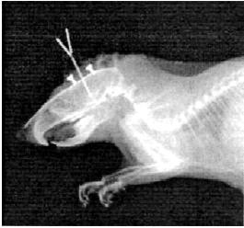
(b) (c)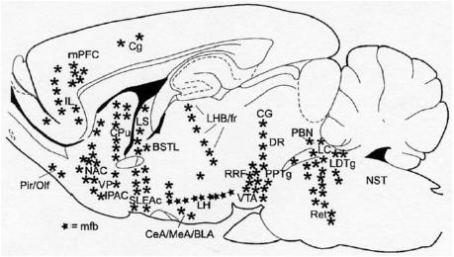
They had no idea where the electrode was implanted, so they took the rat to the x-ray department and took an x-ray picture of it (fig. b). Some guessed that it was probably just in front of the Nucleus Accumbens.
In fact, there are many sites in the brain that are supported the electric cell stimulation (fig. c). The animal would hang out in the place and work for the opportunity to get cell stimulation and that could have interplayed animal bar pressing to receive electrical stimulation in the brain. It would work to get, to turn on the electrical stimulation. In many parts of the brain, not every part, not like no matter where you’ll get the desire, but there are many parts, in the idea of there are circuits within the brain that play an important role for this sort of behaviour and turning on this circuit (turn on a number of different parts of it) would activate this behaviour.

<Slide 11>
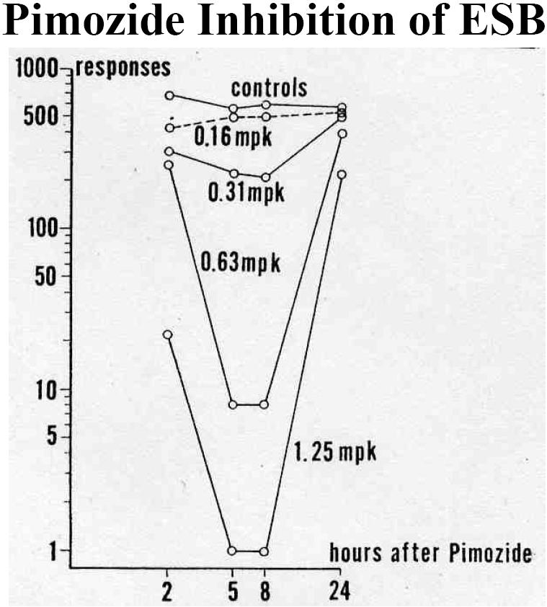
Back to DA, is DA involved? The first evidence that an animal’s willingness to work for electrical stimulation of the brain was related to DA came from studies by Paul Janssen who then formed a pharmaceutical company. He has discovered the DA receptor antagonist called Pimozide. One of the things he observed was that the new drug Pimozide diminished the willingness of the animal to work for electrical brain stimulation reward. The animal seemed to lose interest in the stimulation and no longer willing to work to get it.
So that’s electrical stimulation of the brain. It still uses a really interesting method to explore the role of certain brain circuits in various behaviour, but there is kind of artificiality to it as well. So you then might want to ask, are these systems related to response more natural reward.

<Slide 12>
Feeding
Much of the research about the role of DA in reward was conducted in the context of feeding experiments.

<Slide 13>
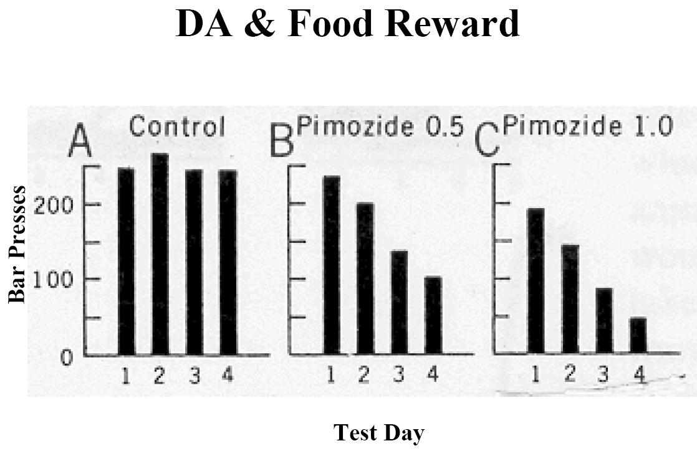
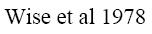
There has been a similar study looking at that question. This is done in a series of some studies that are really important work by Roy Wise in the 1970s. Roy Wise actually did some of the training at McGill and then this is the study that he is most famous for done at Concordia University. His most important work was done in Montreal. If you are interested in this kind of work here, you are in the right place. Basically, what he did is that these animals were training to bar presses to get food.
- A Control: they’ve been food deprived, hungry, they were put in a box and there was a bar. They’ve already learned that if they press the bar, they’ll get some rat food. During the series of four test days, they pressed the bar to get food.
- B Pimozide 0.5: The animals also learned the same task, but they were given a low dose of Pimozide (DA receptor antagonist).
- C Pimozide 1.0: The animals learned the same task, but they were given a higher dose of Pimozide.

For B&C, on the first day, the animals still want to get some food, but after a couple of days, the desire of pressing the bar has been decreased.
Roy Wise interpreted that DA might somehow involve in a pleasure (the yumminess of the food) and he called this,
The pleasure hypothesis: the idea that DA was critical to the spirit of pleasure and shot down the system that’s why animals became less interested in various rewards. (very influential hypothesis)

<Slide 14>
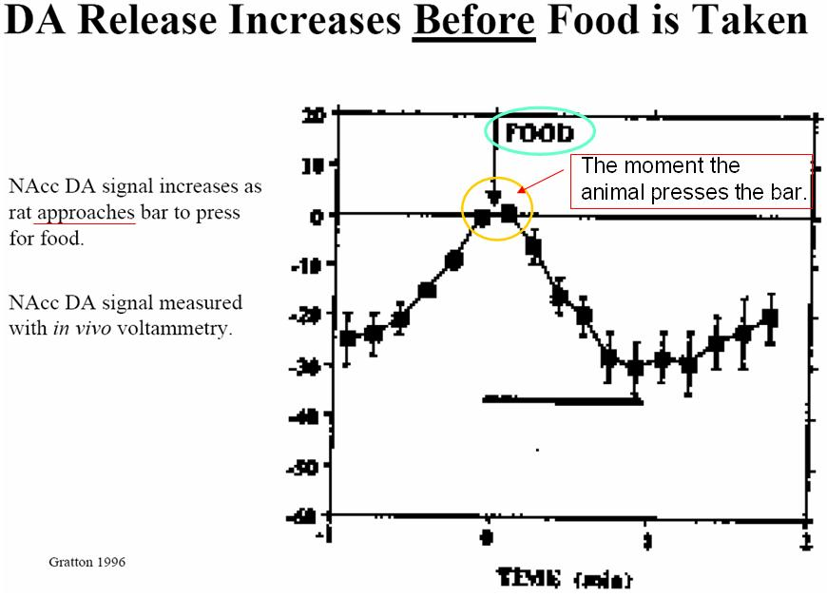
At the same time, there was a work being done that suggested DA is very closely related to interest in rewarding stimuli, not pleasure per se, but the expectation of pleasure. This could be important nuance of what DA might be doing in these kinds of behaviour. One of the important experiments that supported this idea was actually done by one of the Roy’s post-doctoral students Alain Gratton who is now the professor here at McGill. Alain used the technique called in vivo voltammetry. It is a method of measuring extracellular DA level and it’s a nice method because it has very fine temporal resolution. You could see changes in DA signal. What you would have measured was changes of DA signal in Nucleus Accumbens as animal walked toward the bar and pressed it to get the food.
What’s happening is the DA signal going up and up and up as the animal approaches the bar then when the animal presses the bar to get the food, the DA signal goes down. This is completely opposite to what Roy Wise predicted. Roy Wise assumed that the DA signal was related to the food. However, the DA signal would going up “(in rat’s mind) I’m gonna get food, I’m gonna get food, I’m gonna finally get the food.” More consistent with this idea that the Nucleus Accumbens DA signal was related to the interest in getting food, the desire to get food, the expectation of getting something as oppose to the pleasure associated with the reward.

<Slide 15>
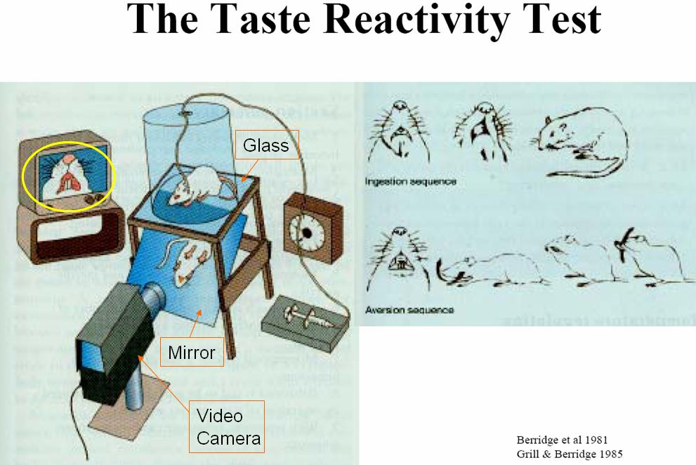
This is another series of experiments; try to get this idea that the DA is important for pleasure per se. The experiment was done primarily by Kent Berridge, an American researcher. In this study, he was videotaping the facial expression on rats when they were administering various flavour of liquid to the mouth. The rat was placed in the cylinder, the bottom was glass, underneath was the mirror and there was a video camera focused on the rat’s face and the signal was recorded then they had a picture of the rat’s face on the monitor. It turns out that rats make different facial expressions depending whether they like the flavour or not. We’ve known (ever since Darwin, 150 years ago) the remarkable similarity of the facial expressions across species in response to various sense of emotional stimuli. So the rats, just like people, they gave them food directly into the mouth (the tube delivered different flavour of substance directly to the animal’s mouth).
Kent then proposed that DA was really important for that “yumminess.” If he shut down the DA system, (ex, DA receptor antagonist or lesion in DA system), he should block the “that’s great” facial expression. However, he didn’t see that and it didn’t happen. When the animal was completely ripped out the DA system and the animal would barely move, but if he delivered the juice to its mouth, the animal would still enjoy the pleasure of receiving the tasty substance delivered to the mouth.

<Slide 16>
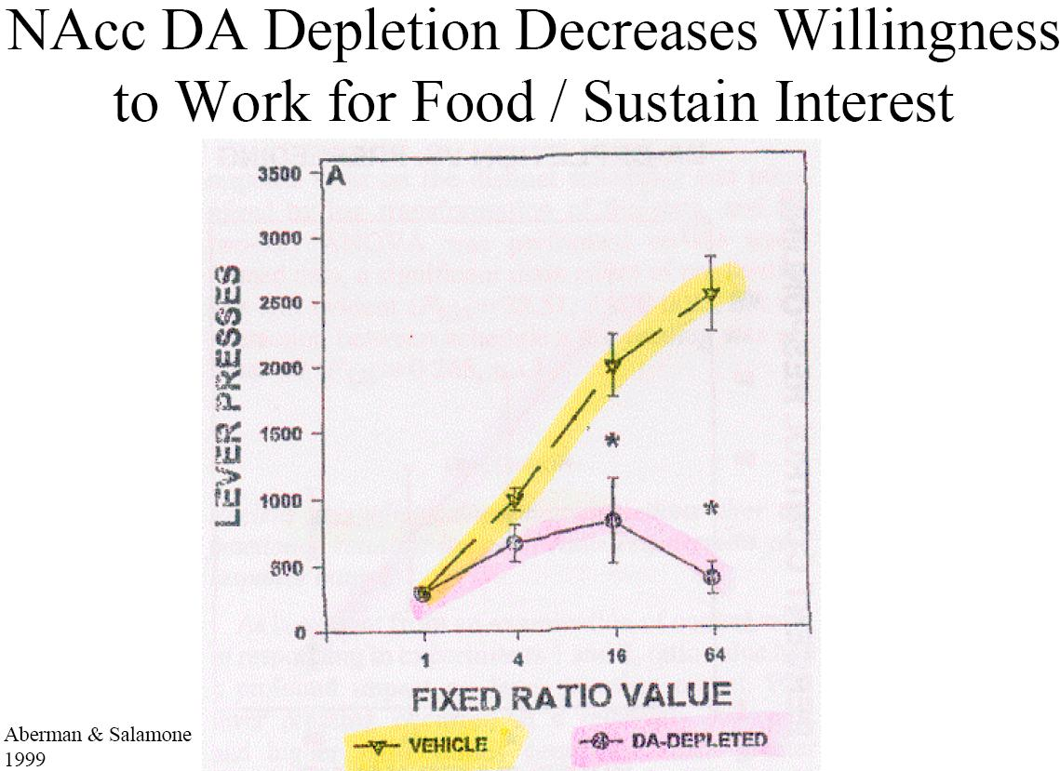
So if DA was not involved in the pleasure per se, what might it be involved?
This experiment showed that they got more at how DA is involved in the interest of obtaining reward. Here, the animals were again bar-pressing to get the food, but here they were really making the animal work for it (the animal could not easily get the food just by pressing the bar once). It has to press 10 times to get food and if it wants a second nugget of the food, it has to press 20 times and then 40 times and so on.
How much does it worth it? How much does it worth to the animal to get that next food?
The controlled animal (the yellow line), when they have been food deprived and they were hungry, they were willing to work pretty hard, up to 2500 times, to get food.
The animals that had DA lesioned (the pink line), the animals have no motivation to work for the food. For them, the food doesn’t worth on the effort. They can’t maintain the interest in the food reward.

<Slide 17>
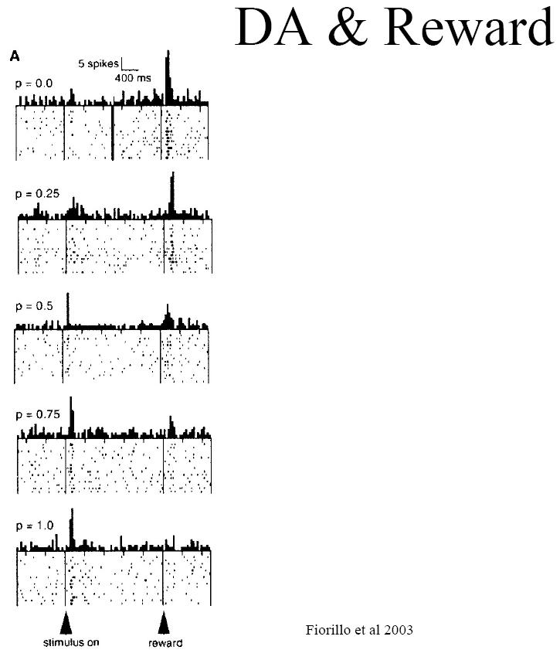
This experiment was worked in Schults’ lab. These studies were being done in non-human primate. He was measuring DA cell firing, electric physiology study (the electrode was implanted in the DA cell body in the midbrain). When he measured DA cell firing, allowed monkey passively receiving juice reward directly to the mouth. The monkey was sitting in the cage and a light comes on.
- At p=0.0, the animal has learned, that light means there are not going to be any reward coming. Then they surprised the animal by sending unexpected juice reward. A big flash of DA signal appeared at the moment of receiving the reward.
- At p=1.0, the stimulus predicted with 100% probability that the juice reward is going to come. Under this condition, now you’ll get a DA cell firing signal in response to the condition stimulus, but not to the reward itself. This again suggests that DA is more related to the “expectation” of the reward (“Ah~ I know the reward is gonna come sometime soon.”) But Not to the pleasure per se because
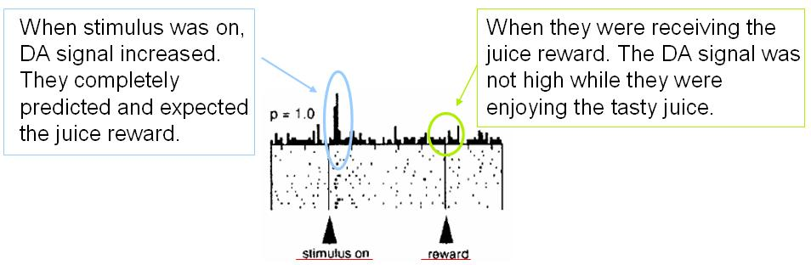
So the DA signal has been occurring in response to the stimulus that predicts the reward as approach to the reward per se.
In response to intermediate stimulus, for example,
- At p=0.75, the animal has learned when they see the light, there is 75% of the chance that they will receive the reward. The animal gave DA response to the predicted stimulus and the little DA signal when it was actually rewarded.
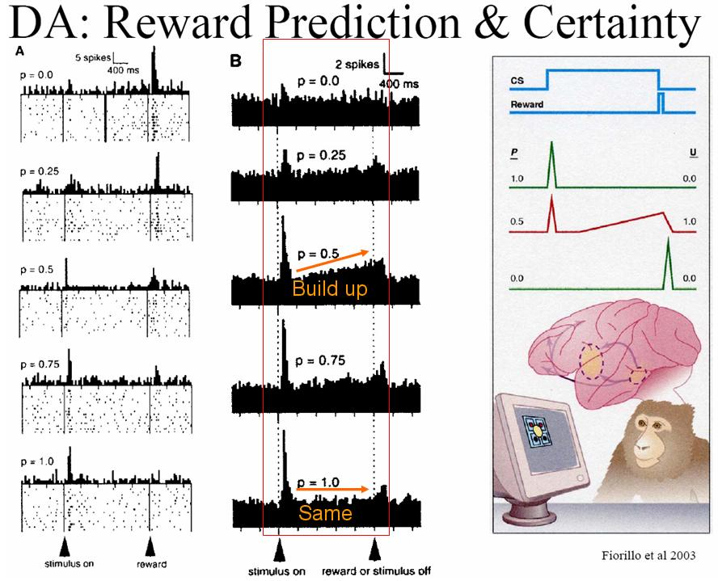
<Slide 18>

Something else seems to occur. During the intermediate period, predicted stimulus and actually receiving reward is also in response to the build up during the expectation and stimulate the magnitude of the response depends on how confident the animal is that the reward is coming. When the animal is 100% certain that the reward is coming, the DA signal is just in response to the predicted stimulus and then nothing goes on during the intervening period. In compared with the animal that is only 50% sure that the reward is coming, you’ll get a response to the predicted stimulus and then (“Maybe I’m gonna get juice”) continue build up the DA cell firing until the animal actually gets the reward of juice.

Question from a student: What do you mean by the animal is 50 or 100% certain that the reward is coming?
Answer from the professor:
The animal was trained and learned certain stimuli predict what is going to be the probability. So, for example, a red light means every time when you see a red light, you are going to receive a banana and every time you see a purple light that means you’ll never get a banana. The animal has done the training and learned that different stimuli (could be visual stimuli or hormone stimuli), they predict various degrees of probability, how likely they’ll receive the juice reward.

This particular system seems to be playing a particularly important role of predicting and expectation of reward or motivation of receiving the reward. In turn, we are sending feedback; we are sending input to the striatal neuron which will modulate different parts of the brain. So if the animal is highly food deprived, it can affect this response (the animal can be more motivated).

<Slide 19>
Sex
The question then arises, does it only related to that kind of natural reward (ex. food reward) or does it involve in other types of reward and clearly another really important type of natural reward through all species is the opportunity to engage in sex.
“The association between striatal DA transmission and sexual behaviour has also been studied. This work provides evidence that the previously discussed associations are not unique to feeding, and instead generalize to all rewards.”

<Slide 20>
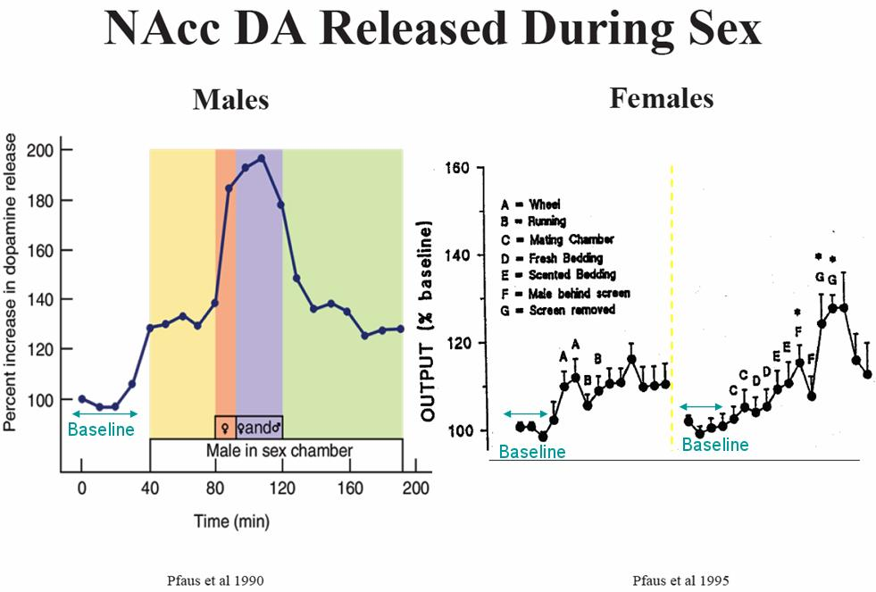
People have measured the DA response in animal during sexual behaviour. This is measuring the DA signal within the Nucleus Accumbens of a male rat that knows that it had a sexual experience and knows that sooner it’s going to have the opportunity to engage in sex.
- Baseline: when the animal has been in one set of cage where it’d never had the chance to engage in sex. So no real changes in DA signal here since nothing is particularly going on.
- Yellow: the animal has been put into the box where in the past it can regularly have the opportunity to engage in sex. So DA signal goes up. (“Okay, something good might happen”)
- Pink: the female is put in a box but there is a wired screen separated. (“There she is, that’s my girlfriend”) DA signal goes way up.
- Purple: the screen is removed. DA signal goes up even more and they are copulating. They are engaging the sexual behaviour and then at this point, the peak indicated the ejaculation. We were expecting the DA signal would be higher post-ejaculation, but no, the DA signal is going up and up as their desire of engaging in sex. Then at the peak moment the signal goes down.
- Green: the DA signal stays down until there is another copulatory series began.

Same thing goes on female rat. The same research was done by James Pfaus who is now at the Concordia University. He did exactly the same thing but in the female brain, measuring the DA signal in the Nucleus Accumbens while before and during the sexual behaviour. When he repeated the experiment, he had some interesting controlled condition.
- Baseline: when female was put in a box and wouldn’t normally be having sex.
- A&B: when female was exposed to a running wheel. (Girls love jogging.)They love running on the wheel. They get all excited and DA signal goes up. A is when they actually step on to the running wheel and start to run. This is a really important controlled condition that the DA signal is going up (“There is the running wheel”) and they get to a jogging. But it is not that physical activity per se that is being producing the increasing of DA signal. It doesn’t go further up once it starts running. It’s the opportunity to go jogging (that makes DA signal goes up).

  - C to G is when the female has the opportunity to engage in sex.
C: they put female rat into a mating chamber. DA signal starts to go up a little bit.
D: they change the bedding at the bottom of the cage, but that doesn’t produce anything
E: they change again the bedding and this time scented with a sense of male. The signal goes up.
F: the male was placed behind the screen and the signal goes up a bit more.
G: when they were actually engaging, copulatory/sexual behaviour. The signal is the highest and then going down again at the end of ejaculatory period.

The same pattern of phenomenon happened in the female Nucleus Accumbens.

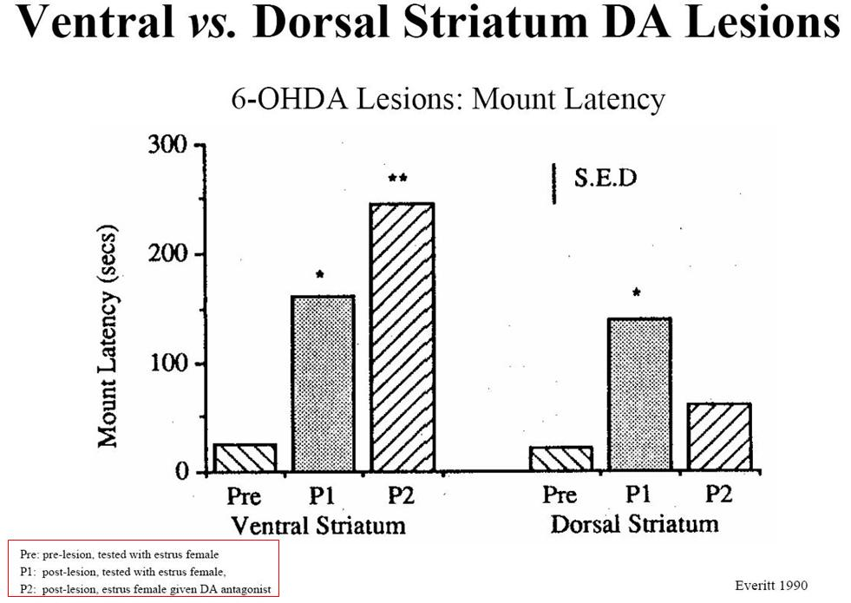
<Slide 21>

The experiment separated out a bit the difference between the ventral vs. the dorsal striatum; ventral being Nucleus Accumbens structure, dorsal structure being more innervated sensorimotor cortex.
This is again the study to measure the sexual behaviour from the male.
Y-axis: Mount Latency (the mounted times that takes them, the male and the female male and female were put together in a box, how long does it take the male to run up to the female and mount her.)
This is a very simple measure, but it has taken in an index of the male’s motivation to initiate the sexual behaviour, how long does it take to approach the female and start mounting.

- The 6-OHDA lesion in Ventral Striatum
Pre: A controlled sexually experienced rat. This happened fairly quickly, in about 30-40 seconds, on average.
P1: the male had the 6-OHDA lesion of the ventral striatum. It slowed down the initiation of mounting, on average about 2 minutes. It was just less interest.
P2: the male had the lesion of the DA system related to the Nucleus Accumbens and the female received the DA antagonist, the drug that blocks DA transmission in her brain. Now both male and female were less interested.

- The 6-OHDA lesion in Dorsal striatum (part of the striatum that is innervated in the sensorimotor cortex). Something different happened here.
Pre: Prior to the lesion, again the male initiated very fast the mounting behaviour
P1: the male rat with the DA lesion in the dorsal striatum. This produces a very similar effect to the lesion in the ventral striatum.
P2: the male rat with the DA lesion in the dorsal striatum was placed with a female rat that had the DA receptor antagonist. The mount latency goes down (the mounting speed goes up).
How do you interpret this →(now the male is faster to initiate mounting)?
Here the animal received a lesion to its dorsal part of the striatum, which is innervated by the sensorimotor cortex. The dorsal striatum plays a role in physical movement, not motivation per se. This is with Parkinson’s diseases; part of the brain has been destroyed. The patient has difficulty in physical movement. However, the ventral striatum here, the Nucleus Accumbens was preserved, so the mal rat still wanted to engage in sex. It just had the difficulty to move. The female that had the DA antagonist was not very interested in sex, but at least she stayed in one place, so the male walked over and he climbed and mounted the female rat.

This experiment really helped to separate out in a really interesting way, the different role of the different part of the striatum in the regulation of these complex natural behaviours.

<Slide 22>
Stress
Now we got a sense that the DA is somehow involved in the expectation of reward, in response to reward stimuli, in the desire to obtain reward.
The observation is that unpleasant events could also increase extracellular level of DA.

<Slide 23>
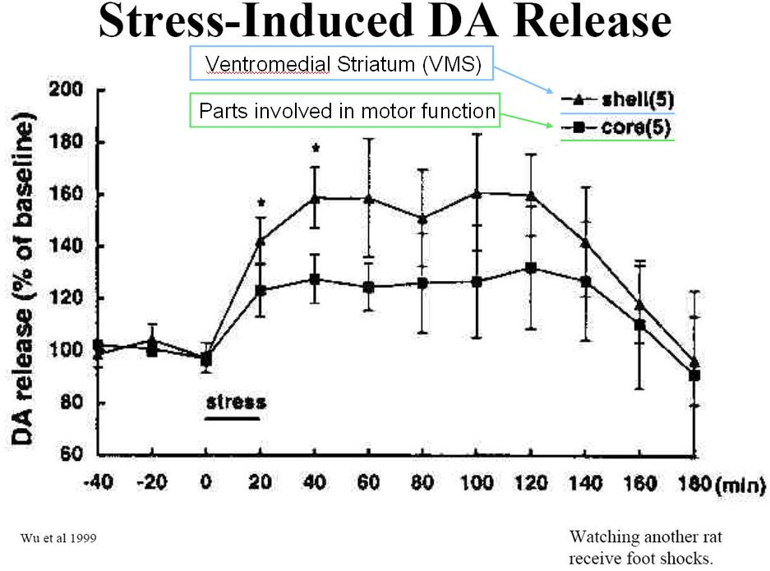
This first reported by Elizabeth Abercrombie in 1989. The rat was placed in a box and there was a Plexiglas separated it from the rat in another box. It saw the rat in another box was getting electric foot-shocks. So the poor rat next door was bouncing around and it saw that. The DA was being measured in the rat that was watching, the stresser without the complication of any kind of physical change per se. Under these conditions, the DA signal goes up. That played an important role in underlining that DA was critical for pleasure. The interpretation is that here the animal was searching for something better, searching to escape, but there was something unpleasant and the animal thought “I’m gonna get out of here, I’m gonna be out to escape from the horrible situation.” So the DA signal plays a role in the animal, looking for something better.
Question from a student: What’s the difference between shell and core?
These are different parts of the Nucleus Accumbens. The shell is the ventromedial part of the striatum and the core starts to move more centrally towards the part that’s involved in motor function.
If we put the rat in a situation that it can’t escape from, then eventually the DA signal goes down because it would give up (there is nothing it can do about it).

<Slide 24>
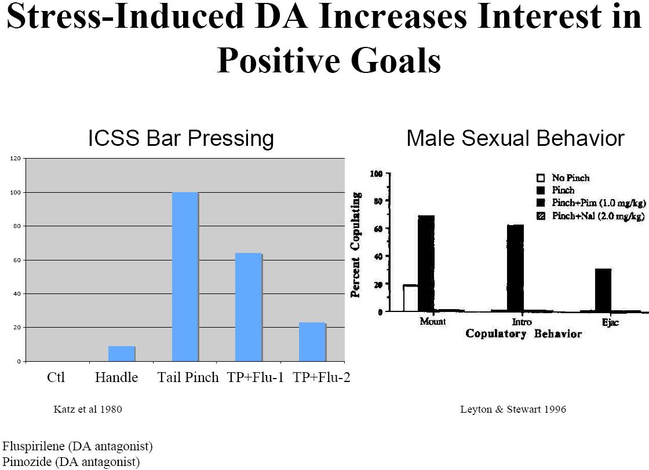
This suggests that DA is more closely related to interest in obtaining something good. In both of these experiments, the animals have been stressed; in this case, they’ve been tail pinch and this induces DA release. We also know that it increases the animals’ sexual behaviour and increases the bar pressing for electric stimulation. If you block the DA system under those conditions, it prevents that effect. DA signal is increased when approach to pleasurable thing.

The lecture ended here.

For information on Slides 25 to 27, please refer to the professor’s note.

